# Linux commands

Filesystem

ls – lists all content in current directory

cd – change directory

pwd – displays path of current directory

mkdir – create new directory

rmdir – removes a directory only if it is empty

rm – removes file from directory

cp – copy and paste file in a specified directory

mv – moves file to a specified location

touch – set last modified timestamp of specified file/s or creates it if it does not exist

cat – list content of files

head – display beginning of file (default 10 lines)

tail – display end of file (default 10 lines)

chmod – change permission for a file

chown – changes user/ group who owns file

ssh – denotes the secure shell

scp – copies file from one computer to another using ssh

sudo run command as a supervisor or another user

dd – copies a file converting it as specified (normally used to copy entire disk to single file)

df – display disk space available and used on the mounted filesystems

unzip – extracts files from zipped file

tar – store or extract files from a tape archive file. Can reduce space by compressing file similar to zip a file

| (pipe command) – allows output form one command can be used as input for another

tree – displays directory and all subdirectories and files indented in a tree structure

& - run command in background with & freeing up the shell for future commands

wget – download a file from the web

curl – download or upload a file to/from a server (deafault: output the file contents)

man – displays a manual page (man man shows manual page of man command)

wc – display number of bytes, words and lines in files

# Search

# Networking

[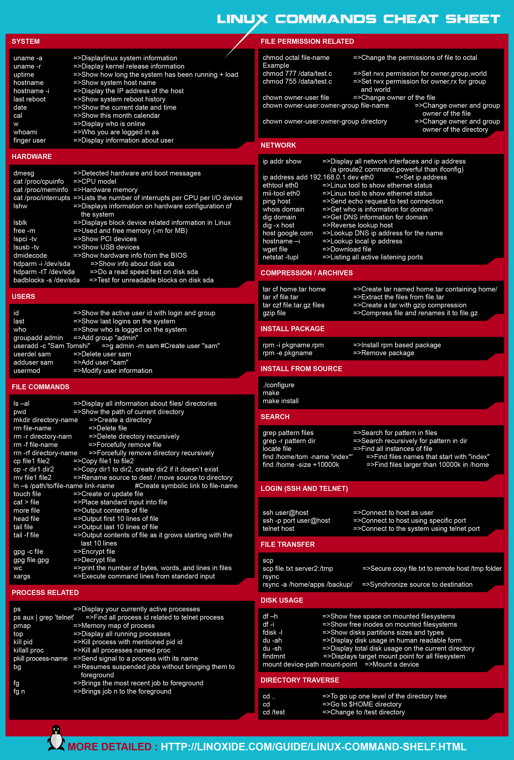](https://i.stack.imgur.com/IzWE4.png)